Change the font of the heading

**Steps to reproduce:**

* Open the <https://www.trgroup.co.nz/> page
* Check the font of the heading

**The font should be changed so it better fits with the rest of the text in the page**

Screenshot:



The video should auto play on scroll in its section of the page instead of popping out

**Steps to reproduce:**

* Open the <https://www.trgroup.co.nz/> page
* Scroll to the video section
* Observe the video section – it does not play automatically
* Click on the video to play it
* The video will pop up and play

**The video should auto play when you scroll to it instead of popping out. There could also be a link to that full video if the user wants to see it.**

Screenshot:

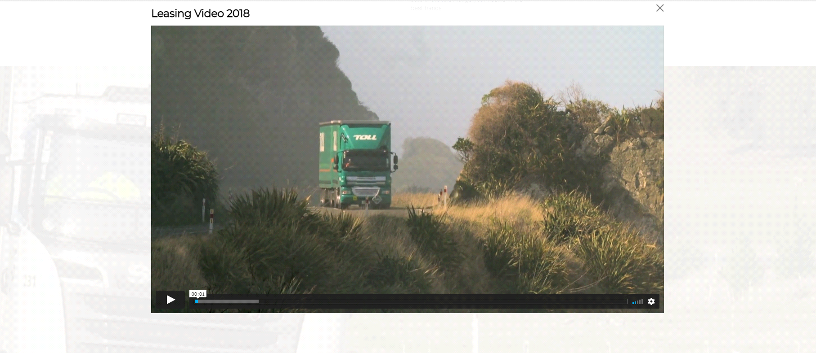

Too much blank space left in the “The TR Group Difference” part of the page and the icons could be centered

**Steps to reproduce:**

* Open the <https://www.trgroup.co.nz/> page.
* Scroll down to “The TR Group Difference” part of the page.
* Observe the icons and the text.

**The first way is explained in the title, the icons should be centered and maybe the icons ant the text rearranged in a way that wouldn’t leave so much blank space on the left.**

**Or it could be done like this: When you hover over the icon you could get the popup text bubble that explains the icon.**

Screenshot:

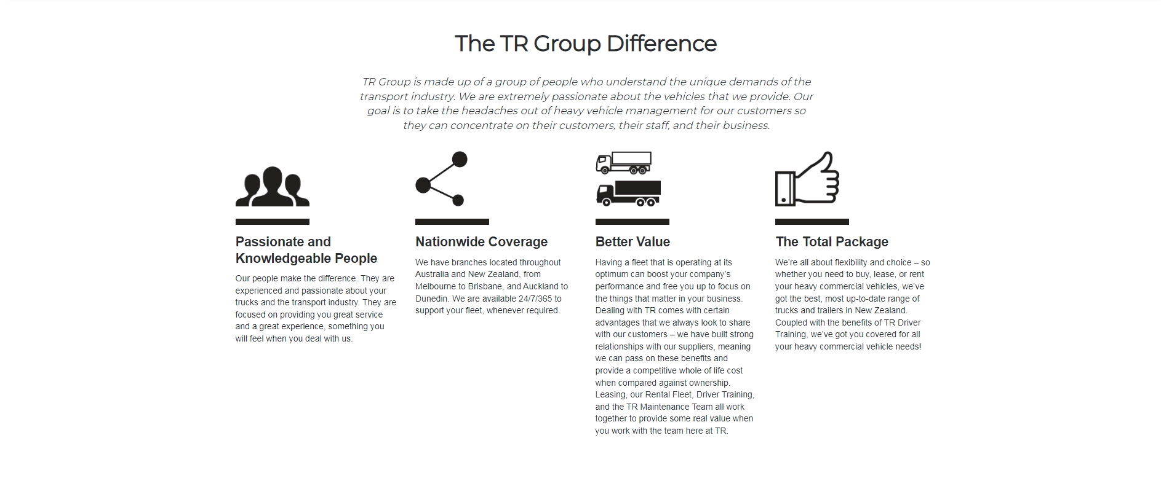

In the “The TR Group Executive Team” part of the page the names should be centered with the above images and contact links should have stronger color change on hover

**Steps to reproduce:**

* Open the <https://www.trgroup.co.nz/> page
* Scroll down to “The TR Group Executive Team” part of the page.
* Observe the names and alignment with the images.
* Observe phone numbers and emails on hover.

**The texts of the names are slightly to the left of center with corresponding images. Emails should have a stronger color change on hover as the desired hover effect is barely visible (first email is hovered on screenshot).**

Screenshot:

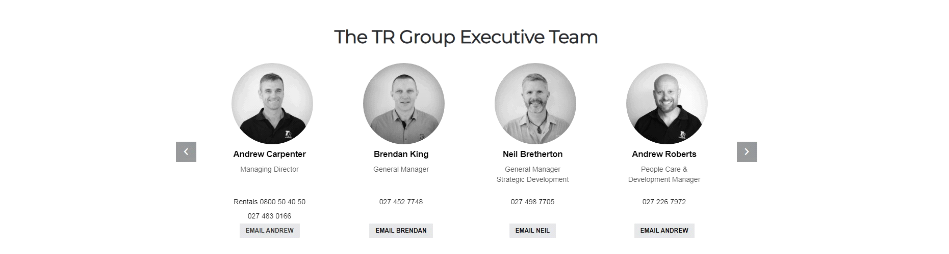

In the Learn More part of the page the lists bullets should not be present and the text should be aligned with the heading

**Steps to reproduce:**

* Open the <https://www.trgroup.co.nz/> page
* Scroll down to “Learn More” part of the page
* Observe the list of links/text

**The bullets should be removed from the list and the links/text should be aligned with the heading above.**

Screenshot:



The background color of the scroll to top button could change its color as it enters different sections of the page

**Steps to reproduce:**

* Open the <https://www.trgroup.co.nz/> page
* Scroll down to the yellow parts of the page so the scroll to top button is barely visible
* Observe the button

**The background color of the button should change as it is barely visible when the background of the site is same yellow color.**

Screenshot:

